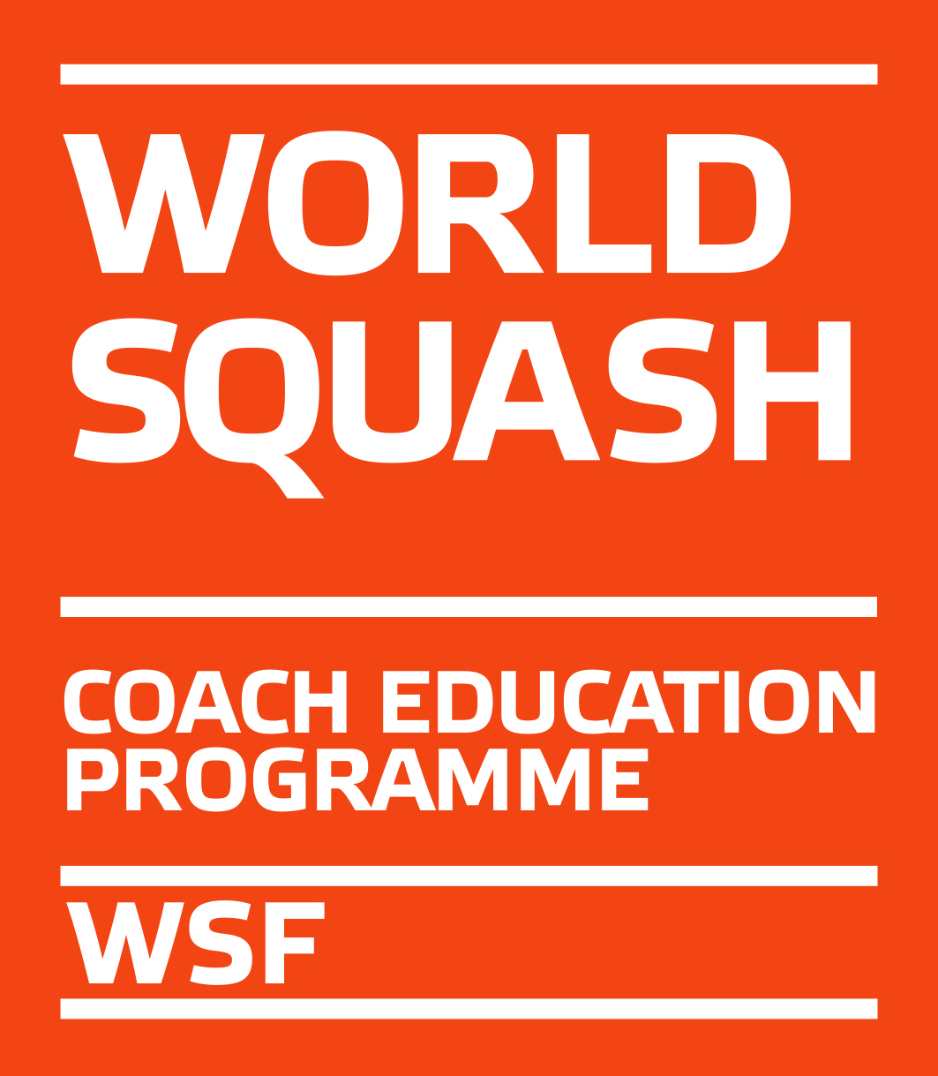


ESF Level 1 Coaching Course

14 - 17 March 2019

Budapest, Hungary

On behalf of the European Squash Federation and the Hungarian Squash Federation we are pleased to invite you to an ESF Level 1 Coaching course.

Course tutor and organizer: Csaba Altvater altvatercsaba@gmail.com

THE VENUE

Griff Squash and Fitness

Bartok Bela ut 152

1113 Budapest

Hungary

COURSE FEE

The course fee of € 250 has to be paid upon entry to following bank account net of bank charges:
Bank: OTP BANK NYRT.
Account No: 11703037-20002994
SWIFT/BIC: OTPVHUHB
IBAN: HU88 1170 3037 2000 2994 0000 0000
Account Name: PRO SQUASH AKADEMIA SPORT EGYESÜLET
Reference: ESF 1

As this course is part of the WSF Coach Education Programme, participants must register with their SPIN on the WSF website (www.worldsquash.org) as L1 Coach Candidate, which costs GBP 16. Please do this before the course starts. Please contact michael.khan@europeansquash.com if you have problems with registration.

ACCOMMODATION

There is a hotel and restaurant in 200m distance. Meals and accommodation are not included in the course fee. For booking accommodation at a special rate or any questions on transport, etc. please contact Csaba Altvater. altvatercsaba@gmail.com

TRANSPORT

Take a taxi from Budapest airport or railway station.

MEALS

There is a restaurant in the Hotel as well as various restaurants near the club, but all meals have to be paid for by the participants.

TIME FRAME

The course will start on Thursday at 10:00 hrs and finish on Sunday at 14:00 hrs.

ESF Level 1 Coaching Course

APPLICATION FORM

Send to:
Csaba Altvater
altvatercsaba@gmail.com

CLOSING DATE: Friday, 15 February 2019

NATIONAL ASSOCIATION ___________________________________

Name ________________________________________

Address ________________________________________

Tel/Fax ________________________________________

E-mail ________________________________________

ESF reserves the right to cancel the course if there are less than 8 entries!

